My Analyis Report
Top Three Expectations from my Clients for my Website
- attract customers: The website has to be visually appealing and highlight the fresh food and interior design of the restaurant. It also should be very welcoming and eye-catching for first time suers.
- Give important info quickly: Customers should be finding what they want to get to very quickly without confusion. Especially essential info like hours, menu, location, and reservations
- Give customers something to remember: The website should reflect the overall vibe of the restaurant and theme of that 5 star sea food experience, to stand out among its competition and build a fire restaurant brand.
Target Audience
- Couples for Restaurant Date Night
- Tourist visiting Tampa Bay
- Seafood Lovers

Three Potential Competitors
- Rusty Pelican on Rocky Point
- Ocean Prime on Westshore Blvd
- Eddie V’s Prime Seafood

Competitor Analysis
Rusty Pelican: The two strengths is that it has great color choices and website design, the weakness is that the website is very images focused which actually causes some lag, and the other weakness is that because of the large images it can actually take too long to find exactly what you want and you end up using more time.
Ocean Prime: This restaurant also has a good luxury feeling color scheme that gives the restaurant this expensive kind of refined vibe to it. It also has a great visual video of the interior for the website. I absolutely love it. The final plus is that it doesn’t feel laggy at all. The weakness is that once you are on the Tampa website it drops in quality and has a lot less images and videos for the menu. This can be seen as a plus; it just depends on what you are looking for. I would also say this restaurant doesn’t attract seafood lovers because it can look a little too high class. It’s hard to find any other cons. I love their website.
Eddie V’s Seafood: This restaurant also has great luxury feeling visuals on the main page along with colors it’s just heavily lacks content and exploration for the users. I think the font for some of the choices on the home screen is too small and the menu looks very plain. One of the biggest strengths is that it has a nice video that repeats of a couple and a bartender pouring alcohol. But it doesn’t showcase the food, interior design, or even anything remotely about what it is like to actually sit in the restaurant.

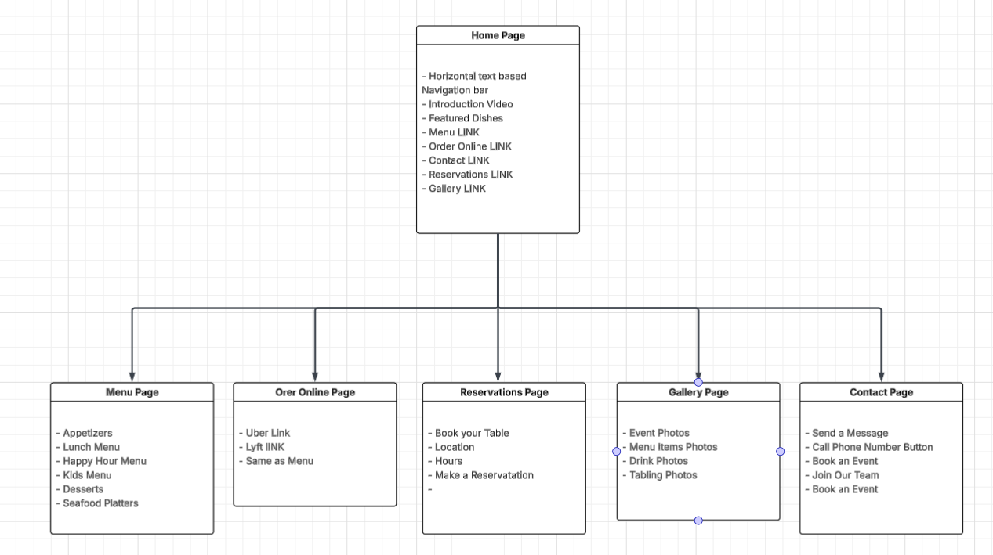
Site Map

Sample Wireframe Page Layout
Color Scheme
Primary Color:
Deep Navy Blue (#0B1F2A) – I want Luxury while still showing the giving ocean sea vibes.
Secondary Color:
Sea Teal (#1F6F78) – showcases the underwater seafood theme but keeping it modern
Accent Colors:
Soft Coral (#E07A5F) – Use this to keep it soft and for call to action (this was a suggestion to me)
Champagne Sand (#F2E9E4) – Adds warmth and balances for the darker colors
Text Colors:
Charcoal Black (#2B2B2B) – Great readability
Muted Gray (#6C757D) – Used for secondary text for content.

Page Layout
Liquid: This will help with flow and overall vibe of the websites. All the other websites used this kind of design principle.

Sample Wireframe Page Layout PT 2
